**Software Requirement Specification**

**PRP_TS ( BATCH NO : 2 )**

1. **INTRODUCTION**
   1. PURPOSE

This document aims at providing requirement specification for PRP_TS (PRP_TRAINING SCHEDULER).

* 1. PROJECT SCOPE

The purpose of the online system is to help PMO (Program Management Office) to create and maintain schedules for employees (freshers), who joins every quarter.

* 1. PROJECT DESCRIPTION

Freshers who joins every quarter, undergo training in various streams. These employees are grouped into batches. The training schedules are created and maintained by PRP PMO team.

The functional requirement of this project is to automate the creation and maintenance of training schedules for each batch.

Each batch consist of following details,

1. Training Stream - Stream for which the training is to be held
2. Batch size - Count of the members in the corresponding batch
3. Training Venue - Place where the training is to be held
4. Start & End date of each modules & sub-modules
5. Faculty for each module or sub-modules
6. Assessment dates for each modules or sub-modules

A unique training number is to be generated for each batch automatically.

Details regarding modules, sub-modules and faculties for each module or sub-module, duration for each module or sub-module, assessment dates are required for creating schedules.

1. **FUNCTIONAL REQUIREMENTS**

The PRP Training Scheduler has four actors. The Administrator or simply Admin can reset others password in case of emergency. The PMO can create and maintain schedules for batches in a training. The employee, Trainer can only view their schedules by simply entering their batch id.

This section describes the use case for each of the actors.

* 1. ADMINISTRATOR USECASE

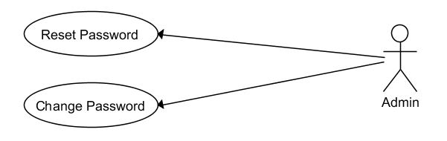

* 1. PMO USECASE

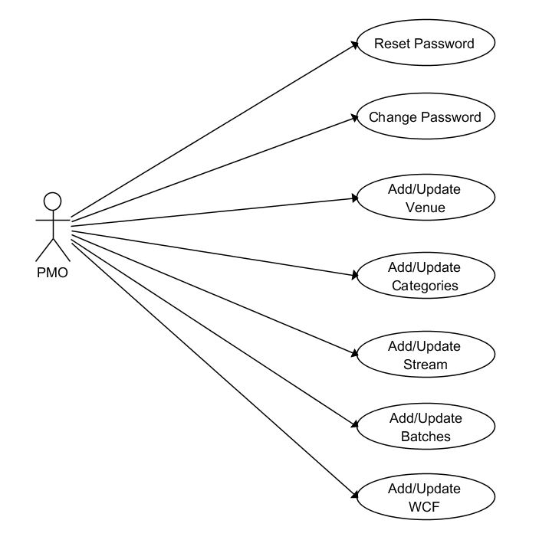

* 1. EMPLOYEE , TRAINER USECASE

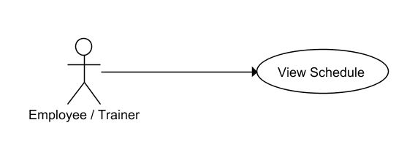

1. **NON-FUNCTIONAL REQUIREMENTS**
   1. PERFORMANCE

The online training scheduler will be run on a server with high speed Internet capability.

During the process update / view schedule response should not be more than 1 second.

* 1. AVAILABILITY

The online system will be available 24 x 7 except in the cases of maintenance of the server / version upgrade.

* 1. CAPACITY

The online system can handle upto 500 users in total if all of them view their schedules.

1. **SYSTEM REQUIREMENTS**
   1. SOFTWARE REQUIREMENTS

Front-end : HTML, JS, CSS, BootStrap

Back-end : Oracle 11g (Hibernate ORM framework)

Environment : Browsers which support HTML & JS

* 1. HARDWARE REQUIREMENTS

RAM : 8 GB (Minimum)

PROCESSOR : 2 GHz *1 (Minimum)

SPACE : 100GB (Minimum)